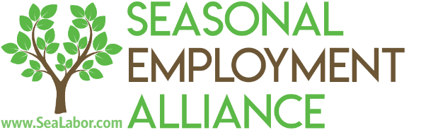
SEA Spring Labor Forum
Hilton Head Island, SC
March 22-24, 2022

Tuesday, March 22nd – Day 1
5:30 PM – 7:30 PM
SEPAC Cocktail Reception hosted by Brian and Veronica Birkenstock
Location: 53 River Club Dr, Hilton Head Island, SC 29926
Join us for a welcome reception at the home of SEA board member Veronica Birkenstock. Dinner and drinks will be served.
Wednesday, March 23rd – Day 2
Labor Forum Location: Colleton, Omni Oceanfront Hotel
8:00 AM – 9:00 AM
Breakfast
Location: Colleton Porch, Omni Oceanfront Hotel
9:00 AM – 9:30 AM
Cap Relief Update
We will provide an overview of our FY 22 cap relief efforts and assess where we are headed into the upcoming season and FY 23 appropriations process.
9:30 AM – 10:15 AM
Overview of union negotiations, next steps
Speakers:
Stephen Replogle, Cove Strategies
Cristina Antelo, Ferox Strategies
Our D.C. lobbying team will provide an overview of our negotiations with LIUNA on FY22 cap relief language and provide their perspective on how should proceed in our negotiations with LIUNA.
10:15 AM – 10:45 AM
Presentation and discussion of FY23 legislative strategy
We will provide the board and SEA membership an overview of our FY23 legislative strategy. This will include our legislative goals, union engagement strategy and a PAC budget.
10:45 AM – 11:15 AM
Northern Triangle Update
Given that most of the FY22 first half supplemental visas have been processed, we can assess the effect of the reforms made by Northern Triangle governments and U.S. consulates on processing times. With a significant NT allocation expected for the second half release, this information will be invaluable to employers who are considering, often out of necessity, bringing in NT workers. We will provide a country-by-country overview so that agents and employers can make the most informed decisions if they decide to request NT workers.
11:15 AM – 11:45 AM
Administration Update
Gary Merson is the point person in the administration on H-2B. He is intimately involved in the supplemental visa release negotiations and in the Northern Triangle initiative.
Speaker:
Gary Merson, Director of Mobility Pathways, National Security Council via video
11:45 AM – 12:15 PM
Discussion of DOL Processing Issues/Regulatory Update
DOL’s inability to process applications in a timely manner, if unresolved, will render the program unworkable. We will present our plan for rectifying this issue before the FY 23 second half filing season. In addition, Leon will provide an overview of the upcoming TFR and rumored rulemaking from DHS and DOL.
6:00 PM – 8:00 PM
Dinner
Location: Coast, SEA Pines Beach Club
Thursday, March 24th – Day 3
8 AM – 1 PM
Golf outing
Location: TBD

